Phoenix Financial Solutions, Inc. Integrates with Car-Ware and BillingTree to provide Loan Servicing to BHPH Dealers in Ohio & Beyond
Press Release-March 8th, 2019
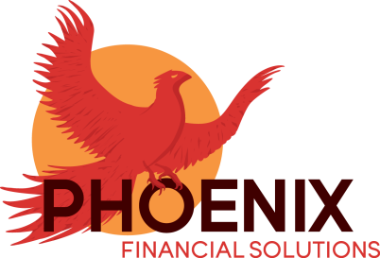
Phoenix Financial Solutions, Inc. located in Ohio, is a company that offers both Loan Servicing and Debt Collection Services to those dealers that choose to engage either wholly or partially in Buy-Here-Pay-Here Financing. For the past ten years, this BBB Accredited company has worked primarily with dealers in Richland, Muskingum and Summit Counties, and has been instrumental in growing the number of active accounts and reducing delinquency rates for their dealership clients. Recently, they have added several Ohio dealerships in Columbus, Cortland and Middletown. Through their time-tested collections techniques, and a concentrated investment in technology and personnel, they have helped reduce their client’s repossession rates and delinquency rates, while at the same time increasing their rate of collections on deficiency balances.
WHAT IS LOAN SERVICING?: “Loan Servicing” gives dealers the ability to concentrate on doing what they do best, which is selling cars, while an outside party handles the day-to-day collections function as well as related activities such as late notices, insurance lapse demands and repossession/auction coordination through the term of the loan. Additionally, and somewhat uniquely, Phoenix Financial Solutions also provides dealers with an avenue to collect on deficiency balances through assignment of debts, which are then primarily collected through the utilization of Civil Judgments.
PAYMENT SOLUTIONS/DMS INTEGRATIONS: Over the past few years, as the agency has transitioned away from using mainly in-house systems, Phoenix Financial Solutions has partnered with both BillingTree and Car-Ware, utilizing different products that they individually offered. Thankfully, and partly because of the increasing need of Phoenix to have both vendors work seamlessly together, a robust integration with Car-Ware and BillingTree has now been achieved. Phoenix is now utilizing BillingTree’s Payrazr Solutions Platform including an enhanced Web Portal, an Integrated Voice Response system (IVR) and the recent addition of a Text-To-Pay and SMS Notifications service, all of which are integrated with Car-Ware.
According to Phoenix President Trisha Keiser, “The level of integration that we have achieved thus far has been the result of working closely with both BillingTree and Car-Ware. Both companies have been great to work with in terms of the customization we needed as a Loan Servicer and offer the products we need to run the company efficiently. I am confident that we have found partners who understand our unique needs, support our sincere desire to be a true extension of a dealership, and also to provide a superior level of customer service to both the dealer and their car customers. Compliance is also a top priority of our agency, and both Car-Ware and BillingTree are equally dedicated to both achieving and maintaining compliance at all times.”
THE PHOENIX DIFFERENCE: As a member of the National Independent Automobile Dealers Association (NIADA) and a Preferred Partner of their state chapter the OIADA, Phoenix is committed to compliance and continuing education in the automotive sales space. The agency offers tiered pricing plans for every size of dealership, including brand new dealers, and rates that are better than or at least competitive with the costs necessary to handle accounts in-house. As the agency continues to work closely with both Car-Ware and BillingTree, and invests in additional in-house technologies and personnel as well, Phoenix Financial Solutions, Inc. is poised to be at the forefront of the Loan Servicing Industry for the State of Ohio and beyond. To learn more about “THE PHOENIX DIFFERENCE” visit them at phoenixcompanies.biz, email them at info@phoenixcompanies.biz or call them at 1-888-741-5936.
